**Productivity Improvement in AICOE**

**Step 1: Business Metrics**

The Artificial Intelligence - Centre of Excellence – (AICOE) is a department in Micron. The AICOE scope is to deliver projects using big data, cloud computing and Artificial Intelligence that can improve yield, quality or reduce costs Micron, one of the world’s largest memory and storage manufacturer. AICOE is an organization comprising 3000+ team members. As AICOE started delivering projects, the net ROI for Micron ballooned from a few hundred crores to more than 1000 crores and so did the costs.

The table below gives the overall financials for AICOE.

|  |  |  |  |
| --- | --- | --- | --- |
| Metrics | FY 2023-24 | FY 2022-23 | FY 2021-22 |
| ROI | 1000 Cr. | 500 Cr. | 300 Cr. |
| Cloud Platform Costs | 20 Cr. | 10 Cr. | 5 Cr. |
| Hardware costs | 10 Cr. | 5 Cr. | 3 Cr. |
| Software Licensing Costs | 5 Cr. | 3 Cr. | 2 Cr. |
| **Employee costs** | **90 Cr.** | **38 Cr.** | **20 Cr.** |
| Travel costs | 3 Cr. | 1 Cr. | 0.5 Cr. |
| Conference/Training costs | 1 Cr. | 0.5 Cr. | 0.25 Cr. |
| Entertainment/Miscellaneous Costs | 1 Cr. | 0.5 Cr. | 0.25 Cr. |

AICOE delivers projects using cutting edge technologies. Employees with this skill come from a hard to find and the demand for these skills is very high as every business wants to build AI teams. Overall, these factors result in a very high cost.

As AICOE grew, the number of projects delivered was linearly proportional to the number of employees that AICOE had, resulting in higher employee costs. The Vice President, who is also the department head of AICOE, wants to drive productivity gain and break the linear increase in costs, thereby reducing overall employee costs for AICOE in coming years.

**Step 2: Breaking down AICOE Employee costs into its drivers**

To understand why the employee cost is high, lets understand how the Overall 3000+ member team is organized. The org structure looks like this

**Team Structure**

Solution Architect

Project Management

Software Development

Data Scientists

Business Analysts

Operations Support

AICOE’s senior management assembled a high-level cross-functional team, named Productivity Improvement Core Team, comprising of team members from Solution Architects, Data Scientists and Machine learning engineers, and mandate this team to identify Gen AI opportunities that could help improve productivity and stop the linear increase in employee costs.

The Core team then set about gathering data and reports from the HR team in AICOE, which falls under the Dept Head, to study the employee costs of each of the departments in AICOE for the last 3 financial years.

By analyzing this report, the Core team prioritized the Data Engineering and Application Support department for deeper study as both these departments have had a significant increase in costs in recent times[1].

|  |  |  |  |
| --- | --- | --- | --- |
| **Department** | **FY 2023-24** | **FY 2022-23** | **FY 2021-22** |
| Project Managers (in Cr.) | 5 | 3 | 1 |
| Business Analysts (in Cr.) | 6 | 4 | 1 |
| Data Scientists (in Cr.) | 12 | 5 | 3 |
| Solution Architects (in Cr.) | 12 | 5 | 3 |
| **Software Development (In Cr.)** | **25** | **10** | **7** |
| **Operations Support (in Cr.)** | **28** | **10** | **4** |
| Others (in Cr.) | 2 | 1 | 1 |
| Total (in Cr.) | **90** | **38** | **20** |

**Step 3: Identify Underlying drivers**

The core team scheduled a series of meetings with the software development team and Operations Support team to understand how the department is structured internally and whether specific teams within the department were incurring higher costs than others. The figure below shows that the Operations Support team had 3 teams internally:

The operations support has 3 teams internally:

1. **Application Support Team:** For any applications delivered by AICOE for Micron, this team supports end users whenever they encounter any problems with the application.

2. **AWS Cloud Support:** AICOE uses AWS cloud platform extensively. This team is tasked with introducing new cloud services, security approval and providing cloud support, whenever development team encounter any issues with cloud services.

3. **Snowflake support:** Snowflake support teams like the AWS Cloud platform team is tasked with introducing new Snowflake features, security approval and providing snowflake support, whenever development team encounters any issues with cloud services.

Once the Core team analyzed the costs of the 3 teams, they found that the Application support team was incurring a very high rate of increase in employment costs. When they contacted the Application Support team manager for the process flow diagram, they found that as part of Micron’s consolidation efforts, the team had received huge number of Analytics applications they had to support apart from the applications that AICOE was productionizing, as a result employee head count increased drastically resulting in huge employee costs.

**Figure 3 – High-level Process Flow for the Application Support Team**

**Step 4 – Studying the Application Support Team process flow and identifying Gen AI opportunities**



End users Log Incidents

Support Team Receive Incident



Manual Resolution of All incidents (Complex or Simple)



Resolution & Documentation

Notification to End users



End users

Having obtained the updated process flow diagram, the productivity improvement core team then set to do a detailed process study of each step of the process. Along with the Application Support manager, the core team organized sessions with the Application Support team to do a detailed analysis of their work and carry out time-and-motion studies.

The different activities that the Application Support team did while resolving the incidents were:

* Incident: Did I understand the incident?
* Incident: What’s the impact of the incident?
* Incident: What’s the severity of the incident?
* Incident: What’s the frequency of the incident?
* Incident: How many times and under what conditions does the user face the incident?
* Knowledge Base: Has the incident occurred previously? Does the incident database already have similar incidents with known resolutions?
* Knowledge Base: Has a KBA (Knowledge base article) been provided by Dev team with standard resolution steps?
* Knowledge Base: Did I receive any email from Cloud/Snowflake/Infra teams of a service failure?
* Processing: Is it an application bug, performance issue, Hardware failure?
* Processing: Can I replicate the issue in Dev/Test environments?
* Processing: Did I get an answer from my knowledge base? Can I fix the incident?
* Processing: Do I escalate it to L3/L4 Team?
* Processing: Is the fix simple and small? Complex and Large?
* Processing: Fix the incident if small, if its complex seek help from L3/L4 teams
* Documentation: Resolution entry into system
* Documentation: Submit resolution
* Documentation: Send notification to customer

The various activities were done manually without the aid of any automation and took a lot of time to carry out. Based on internal brainstorming, the Productivity Improvement Core Team identified the following opportunities within Application Support team for Gen-AI-based automation.

1. **Incident Matching Automation** – Use Gen AI to understand the incident, search the incident database and provide matching incidents along with any known resolutions.
2. **Doc Search Automation** – Use Gen AI to search all documents, KBA’s and emails to provide known answers to the questions by Support teams.
3. **Notification Automation** – Use Gen AI to notify L3/L4 teams, end users and leadership teams
4. **Data entry and Doc automation** – Use Gen AI to accelerate data entry into systems and generate documents for future references.
5. **Operations AI Agent** – For all simple, low impact, and high frequency incidents with a very well-known incident resolutions, let the agent identify incidents, process the incident automatically, document the incident and send the notification to customer.
6. **Budgeting Alert & Resolution Automation**: Use Gen AI, identify projects that consume more than allocated budgets and provide known resolutions to project teams.
7. **Service Failure Notification Agent:** Use Gen AI to identify service failures within cloud platforms, raise incident with the cloud vendor, and notify AICOE teams with constant updates.

**Step 5 – Prioritization & Blue-Chip Identification:**

**Projects in Horizon 1:** For AICOE and its efforts towards using Gen AI to reduce employee costs, the **Notification Automation**, **Data entry and Doc Automation,** and **Service Failure Notification Agent** mentioned in the previous step were identified as opportunities that could be pursued immediately with little development efforts and were slotted **into Horizon 1**.

**Projects in Horizon 2:** The **Doc search Automation** and **Budgeting Alert & Resolution Automation** were slotted into Horizon 2 project as development of these features would require relatively more work and is more complex and needed deep expertise.

**Projects in Horizon 3:** For AICOE, using Gen AI for **Operations AI Agent (**automating the entire Incident resolution process for Simple incidents) and **Incident Matching Automation** could be considered as a moonshot as not only would it significantly cut down the manpower required but it would also delight customers who could receive a decision much faster.

The core team prioritized the development of these initiatives within horizons using the prioritization matrix below:

**Table 3 – Prioritization Matrix – Snippet (Criteria in rows, Gen AI Opportunities in Columns)**

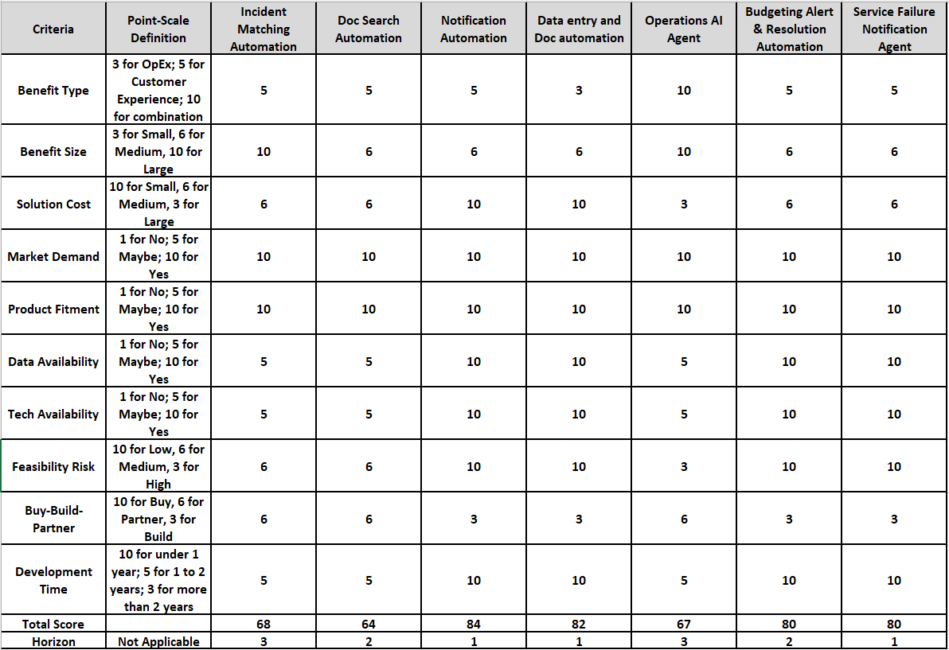

Based on the combined score for each opportunity, arrived at using the prioritization matrix, the Productivity Improvement Core Team was able to prioritize the Blue Chips, and these were then presented to the VP, Department head to complete the original mandate that was given to the team.

1.